Willow Primary Academy
The Piper Centre

Behaviour and Relationship Policy

Willow Primary Academy
The Piper Centre –
Taking PRIDE in all we do

Promoting Positivity, Nurturing Respect, Celebrating Individuality, Fostering Determination, Striving for Excellence
Policy Review Schedule

Date agreed: September 2023
Next review due: September 2024
Distributed to staff: September 2024
Signed by SLT: P Hales
Signed by chair of governors: W Ward

Early Help Coordinator | Nikki Hendry
SENDCO Main school | Beth Griffin
SENDCO Piper Centre | Mandy Walton
Designated Safeguarding Lead | Nikki Hendry
Deputy Designated Safeguarding Leads | Debra Arthur, Pete Hales, Mandy Walton & Carly Tonks

Early Help
Early help means providing support as soon as a problem emerges, at any point in a child’s life, from the foundation years through to the teenage years. Early help can also prevent further problems arising; for example, if it is provided as part of a support plan where a child has returned home to their family from care, or in families where there are emerging parental mental health issues or drug and alcohol misuse.
Effective Early help relies upon local organisations and agencies working together to:
• identify children and families who would benefit from early help.
• undertake an assessment of the need for early help.
• provide targeted early help services to address the assessed needs of a child and their family which focuses on activity to improve the outcomes for the child.

‘Early Help’ is an umbrella term that describes the work of many agencies engaged with children and families including health services, schools, learning providers, local authorities, voluntary sector, children and family centres, police, housing providers and many others. We are all engaged to a greater or lesser extent in work that seeks to avert a problem developing and preventing difficulties from escalating or the deterioration of circumstances which could adversely affect children, young people and families.
There is a large body of evidence on the impact of adverse childhood experiences (ACEs) on the health and well-being of children and young people that can persist into adulthood. The more adversity a child experiences the more likely it is to impact upon their mental and physical health. This underlines the importance of early help, particularly through developing positive relationships with trusted adults, which has been shown to build resilience and mitigate the impact of ACE’s on child and adolescent development. It also stresses the importance of whole-family working in early help in order to understand and address ACEs in adults that may impact on their capacity to care for their children.
Early help is about focussing on how we can help people to do things for themselves and build on strengths within families. If we can get this right early on, at the right time, we get the opportunity to help people with areas of their life they may be struggling with, which sets people up for a better long-term future. It is also about providing support at any and every stage of a child’s life: pre-birth, during pregnancy, childhood and/or early adulthood.

As a school we will follow the Gloucestershire Practice Guidance; gcc_2387_early_help_practice_guide_digital_dev6.pdf (openobjects.com)
And use the Gloucestershire levels of intervention guidance- gloucestershire-revised-loi-guidance-v7-dec2021.pdf

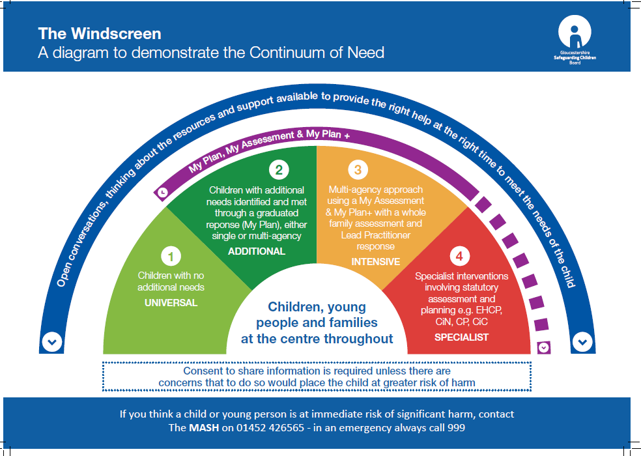

Any child may benefit from early help, however; we are particularly vigilant to the potential need for early help for a child who:
• is disabled or has certain health conditions and has specific additional needs
• has special educational needs (whether or not they have a statutory Education, Health and Care Plan)
• has a mental health need
• is a young carer
• is showing signs of being drawn in to anti-social or criminal behaviour, including gang involvement and association with organised crime groups or county lines
• is frequently missing/goes missing from care or from home
• is at risk of modern slavery, trafficking, sexual or criminal exploitation
• is at risk of being radicalised or exploited
• has a family member in prison, or is affected by parental offending
• is in a family circumstance presenting challenges for the child, such as drug and alcohol misuse, adult mental health issues and domestic abuse
• is misusing alcohol and other drugs themselves
• has returned home to their family from care
• is at risk of ‘honour’-based abuse such as Female Genital Mutilation or Forced Marriage
• is a privately fostered child, or
• is persistently absent from education, including persistent absences for part of the school day.

All staff will identify the need for prevention and early intervention and offer the ‘Right help at the right time’ by using some of the following examples of early help:
- Having an approachable open door policy for all parents/carers and children
- Pupil Progress meetings
- Available supervision/consultation with Designated Safeguarding Lead/Deputy Designated Safeguarding Lead
- Family support work
- SENDCo support; My Plan reviews, My Plan + reviews, Annual reviews
- Support for pupils who are Pupil Premium
- Meeting with Family Welfare Officer/Designated Safeguarding Lead
- My Plan + assessments
- Team Around the Child/family meetings
- Signpost families to services e.g. Family Lives
- Referrals made to relevant agencies e.g. Paediatrician, CYPS, School Nurse, Young Carers, Winston’s Wish, Youth Support, Greensquare
- Referral to Families First plus team if relevant in order to support the family through Triple P Parenting group or Family Support Work
- Referral/advice from Community Social Worker (involve CSW in any relevant meetings)
- Support/ give information on Gloucestershire Family Information Service
- Strong links and liaison with other agencies e.g. Children Centres, preschools, Police, hosing, health visitors
- Good liaison with previous setting when a child transfers to Willow Primary Academy and The Piper Centre
- Behaviour support Plan in place

Record-keeping
Early Help is flagged and recorded on a secure communications system called CPOMS.

CPOMS is the market leading software application for monitoring child protection, safeguarding and a whole range of pastoral and welfare issues. Working alongside a school’s existing safeguarding processes, CPOMS is an intuitive system to help with the management and recording of child protection, behavioural issues, bullying, special educational needs, domestic issues and much more. Using CPOMS, schools can ensure that students are safe and fully supported, whilst school staff can focus on teaching and providing support, instead of administration.
Every member of staff across school has an obligation to report any concerns which they may have. CPOMS allows them to record information in a central repository and have relevant people alerted immediately. Senior leaders are able to build a chronology around a student and can produce reports on vulnerable pupil groups for Case Conference Meetings, Governors and Ofsted
CPOMS Systems Limited (CPOMS) is committed to maintaining compliance with all relevant EU and Member State laws in respect of personal data, and the protection of the rights and freedoms of individuals whose information we collect and process in accordance with the General Data Protection Regulation (GDPR).

School Indicators for Children or Families That May Require Early Help
The following list provides examples of areas where, without intervention a family may break down or a child may be put a risk of neglect, emotional, physical or sexual harm. This also includes the risk of extremism. The school has no pre-prescribed criteria for supporting children and families. Each case is assessed according to needs and a bespoke programme put in place for that child and/or family:

Indicator | Indicator | Indicator | Indicator
Low Parenting Skills  Substance/Alcohol Abuse  Domestic Abuse  Child Mental Health  Bereavement  Child Unaware of Danger and How to Keep Themselves Safe  Extremist views | Poor Diet - Obesity, Malnourished  Young Carer  Breakdown in community relationships  Adult Mental Health  Changes in Behaviour and Risk of Exclusion  Child Demonstrates Sexualised Behaviours | Low Income or Poverty  Breakdown in family relationships  Isolation  Disability of a Child  Poor Attendance and Punctuality  Frequent House or School Moves | Transport  Special Educational Needs (refer to Local and School offer)  Disability of an Adult  Child Unaware of How to Keep Themselves Safe Online  Cleanliness and Hygiene

Example Early Help Points of Contact
The school has divided its Early Help strategies into 4 areas: Universal Support is for all and is what all children and families would normally receive, Community Support is for a child or family who may need some extra support, Specific Support is for children and families who need specialist support and Acute is where a child or their family need a high level of support to prevent harm.
Universal Support | Community Support | Specialist support | Acute support
Family  Friends  School Staff  Governors  Parent Teacher Association  Breakfast Club  After School Clubs  Community Clubs (i.e. sports, arts etc.) | Family Support Worker  Inclusion Manager  School Safeguarding Team  School E-Safety Team  Police Community Support Officers (PCSOs)  Police  GP  Health Visitor  Midwife  School Nurse  District/County Council  Food Bank  School Staff  LA SEN Team  Landlords  Young Carers  Citizens Advice Bureau  Job Centre  Traveller Support Services  Interpreter  Education Performance and Inclusion Team (EPIT)  Children's Centre  Communication with Previous Settings | Families First + Team  School Safeguarding Team  Social Care (Initial/Core Assessment)  Parenting Courses (Webster Stratton, Triple P,  Paediatrician  Counselling  Play Therapy  Art Therapy  1:1 Therapy from Specialist Therapists  Children and Young People's Services (CYPS)  Education Performance and Inclusion Team (EPIT)  Physiotherapist  Green Square  Keep Safe Work  Occupational Therapist | Social Care - Child Protection (CP), Child in Need (CIN)  School Safeguarding Team  Social Worker  Police - Police Protection Order (PPO)  Courts - Care Proceedings  Counselling

Examples of sources of support and links that Willow Primary Academy and The Piper Centre staff and families may use are (please note this is not extensive):

Provision | Details
Adverse Childhood Experiences(ACES) | Willow Primary Academy and The Piper Centre are supporting the Gloucestershire project Action on ACEs. An understanding of this helps us identify pupils who need Early Help and are we are in the early stages of working to adopt approaches that help children and families build resilience.  https://www.actionaces.org/
Advisory Teaching Service | help children and young people participate and achieve in all aspects of life:  - by developing the skills of the individual and those of their families, schools and settings  - through collaborative working in which the voice of the child is paramount  https://www.gloucestershire.gov.uk/education-and-learning/special-educational-needs-and-disability-send/advisory-teaching-service/
Bereavement | Winstons Wish, Cruise
Breakfast Club | Willow Primary Academy have an onsite Breakfast club from 8am-8.45am
Children in Care | Virtual School  Designated Teacher: Mr Pete Hales
Children Missing Education | Education Performance and Inclusion Team. All unauthorized absence over 10 days is reported to the Local Authority unless the child is in care or on a child protection plan then the absence is reported after 2 days. All staff are aware of the Child Missing Education protocol.
Child Sexual Exploitation | Gloucestershire Healthy Living and Learning (GHLL), Nigel Hatton, NSPCC – Pants Rule  By using GHLL and NSPCC resources we provide children with information on healthy relationships. https://www.gov.uk/government/publications/what-to-do-if-you-suspect-a-child-is-beingsexually-exploited  Screening tool available on the GSCB website http://www.gscb.org.uk/article/113294/Gloucestershire-procedures-and-protocols
Domestic Abuse | Gloucestershire, Domestic Abuse Support Service (GDASS), Your Future, Crush, ISIS Women’s Centre https://www.gov.uk/domestic-violence-and-abuse  Children and young people are often the forgotten victims of domestic violence/abuse. They may suffer direct physical, sexual or emotional abuse, or the abusive impact of witnessing or being aware of abuse to their mother or father.
Educational Psychologist | Willow Primary School can have support from an Educational Psychologist.
Fabricated or induced illness | https://www.gov.uk/government/publications/safeguarding-children-in-whom-illness-isfabricated-or-induced
Faith abuse | https://www.gov.uk/government/publications/national-action-plan-to-tackle-child-abuselinked-to-faith-or-belief
Female Genital Mutilation (FGM) | https://www.gov.uk/government/publications/female-genital-mutilation-multi-agency-practiceguidelines  Professionals in all agencies, and individuals and groups in relevant communities, need to be alert to the possibility of a girl being at risk of FGM, or already having suffered FGM. DSL has completed the Home Office Training
Financial Hardship | GL Communities, Citizen’s Advice Beureaux (CAB), Department for Work and Pensions, Christians against Poverty (CAP), One Church, Barnwood Trust, Free Hospital Trust Fund, Food Back
Forced Marriage (FM) | https://www.gov.uk/forced-marriage
Gangs and youth violence | Avengers Task Force, Great Expectations, Aston Project, Local Community Police Officer https://www.gov.uk/government/uploads/system/uploads/attachment_data/file/226 293/Advice_to_Schools_and_Colleges_on_Gangs.pdf
Gender-based violence/violence against women and girls [VAWG] | https://www.gov.uk/government/policies/ending-violence-against-women-and-girls-in-the-uk
Glos Families Directory | Families and professionals can be signposted to lots of support services through the Gloucestershire County  http://www.glosfamiliesdirectory.org.uk/kb5/gloucs/glosfamilies/family.page?familychannel=2
Honour Based Violence (HBV): | Honour based violence is a crime or incident, which has or may have been committed to protect or defend the honour of the family and /or community.
Housing Issues | Gloucester City Homes, Green Square
The Key | The Gloucestershire Disabled and young peoples register and information service  Email- thekey@gloucestershire.gov.uk  Telephone-08000093443
Mental health | Children and Young People’s Service (CYPS), Adult Mental Health Services, Teens in Crisis Counselling https://www.gov.uk/government/publications/the-mental-health-strategy-for-england  A member of staff has attended Mental Health First Aid Training
Private fostering | https://www.gov.uk/government/publications/children-act-1989-private-fostering
Radicalization | https://www.gov.uk/government/publications/channel-guidance  Staff have undertaken an e-learning prevent training package. Senior staff are confident how to refer to the Channel Panel.
Relative in Prison | Infobuzz
Sexting | Gloucestershire Healthy Living and Learning (GHLL) http://ceop.police.uk/
Substance Misuse | Turning Point, Gloucestershire Healthy Living and Learning (GHLL), Facts 4 Life https://www.gov.uk/government/uploads/system/uploads/attachment_data/file/270169/drugadviceforschools.pdf
Suicide Prevention/Self Harming | Children and Young People’s Service (CYPS), Adult Mental Health Services, Teens in Crisis Counselling Schools can access advice through the CYPS Professional Helpline number and is aware of who the schools Primary Mental Health Care worker is. The school is also aware that labels with helplines can be obtained from the GSCB as and when required.
Teenage relationship abuse | Gloucestershire Healthy Living and Learning (GHLL) https://www.gov.uk/government/collections/this-is-abuse-campaign.
Trafficking | https://www.gov.uk/government/publications/safeguarding-children-who-may-have-beentrafficked-practice-guidance
Young Carers | Gloucestershire Young Carers.  www.glosyoungcarers.org.uk/

