The Piper Centre

British Values Statement

The Piper Centre –
Taking PRIDE in all we do

Promoting Positivity, Nurturing Respect, Celebrating Individuality, Fostering Determination, Striving for Excellence

Our British Values Statement

At The Piper Centre we promote British Values through our spiritual, moral, social and cultural education which permeates through the school’s curriculum and supports the development of the ‘whole child’.

At The Piper Centre, we recognise that such development is most successful when those values and attitudes are promoted by all the staff and provide a model of behaviour for our pupils.

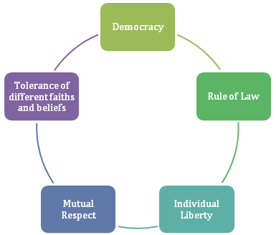
‘British Values’ have been identified as:

Democracy:
- The ability to communicate is the most important area of learning. At The Piper Centre we ensure that pupils are given a ‘voice’ to communicate. The method of using this ‘voice’ could be using words, objects, photographs, pictures, symbols, touch cues, eye pointing, body language or an electronic communication aid.
- We empower our pupils by giving them opportunities to make choices about the things that they believe to be important. By valuing each ‘voice’ and by listening and responding to that voice we demonstrate that we support democracy and liberty.

Rule of Law:
- Pupils are helped to learn to manage their behaviour and take responsibility for their actions.
- Staff are committed to providing a consistent and predicable environment within the school and beyond. We can help some pupils to understand the connection between actions and consequences. This type of environment enables pupils to feel safe and secure; this in turn, promotes the optimum conditions for learning to take place.

Individual Liberty:
- Pupils at The Piper Centre are encouraged to become good and valued citizens. We do this by supporting each pupil to become as independent as possible.
- We endeavour to demonstrate that everyone has rights; this includes the right to say ‘No’ to ideas or activities that they do not want to take part in or makes them feel uncomfortable. Some pupils will be able to take responsibility for particular roles and to understand that with certain rights comes a level of responsibility. Learning to do things independently is an important part of learning to understand yourself.
- We support others by participating in charitable events such as, Red Nose Day/Comic Relief, Children in Need and Jeans for Genes Day. At The Piper Centre we believe that by engendering a caring and helpful environment and by learning to be independent can boost and nurture a healthy self-esteem.

Mutual Respect:
- We promote each pupil’s inclusion, where possible, in a range of activities, settings and locations.
- Planned events and activities are organised for pupils to go into the community to meet with a range of people in a variety of situations which include: sports events, community events and shared participation with other schools/colleges.
- It is important to facilitate opportunities for The Piper Centre to be part of the community as the pupils, families and staff have much to offer in the development of community cohesion.

Tolerance of different faiths and beliefs:
- The Piper Centre serves a multi-faith community where each person is respected and valued equally without regard to ability, gender, faith, heritage or race.
- Cultural appreciation and development forms part of our curriculum. We place great emphasis on providing opportunities to participate in events and celebrations which broaden all pupils’ experiences and awareness of others.
- Our Assemblies help all pupils to find out about themselves and others, linking their lives to the communities to which they belong. The themes cover areas such as: friendships, helping others, going for goals, getting on and falling out, and celebrations from a range of faiths and world events. Our assemblies are also a celebration of pupil achievement.
- Pupils are encouraged to experience British culture and values through our curriculum themes. Pupils visit a wide range of local and national venues, including day trips. We also invite visiting theatre groups to perform plays.
- The staff work closely with parents, carers and other professionals to ensure that the pupils at The Piper Centre are happy, well cared for and enabled to learn the skills they need to live a fulfilling life as part of their community.

